README

Hello, Dendrophil is open source software for make easy painting phylogenetics trees. For input we use svg-files after figtree.

How to use:  
  
We recommendation use latest version python at official site:   
<https://www.python.org/>

How to install:

Install for Windows.

Download latest version python (actual for this readme 3.7.3)

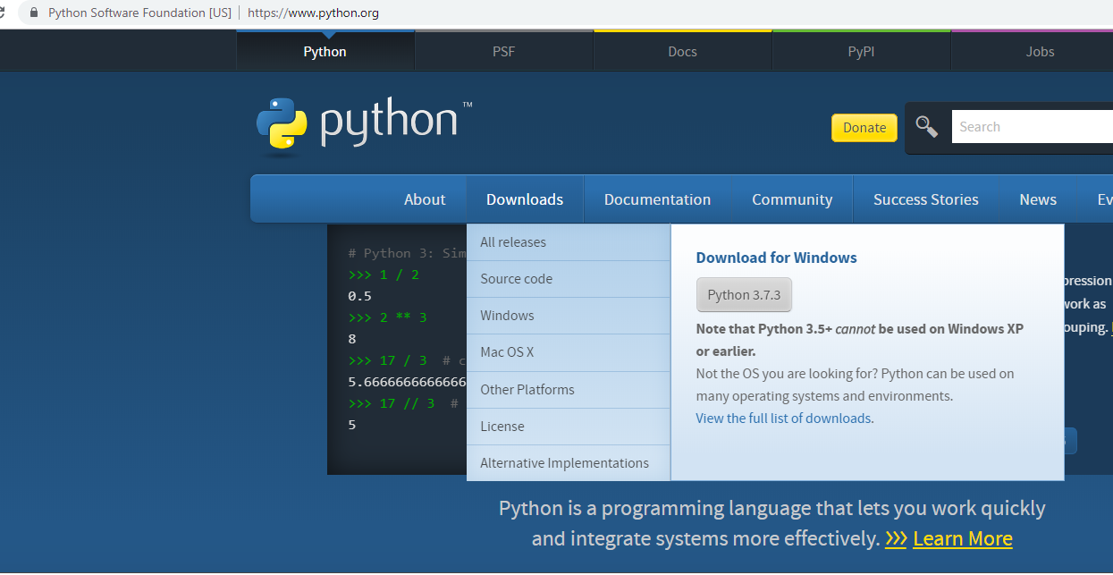

After download – double click to starting install.

ATTENTION!  
Don’t forget choosing flag at button “Add Python X.X.X to PATH”. It’s needs for easy install module with pip. 

After installing we needs check correctly install.

Open command prompt (cmd.exe in windows search)



Write

**python**

If installed completed, you can see python! Congratulation!

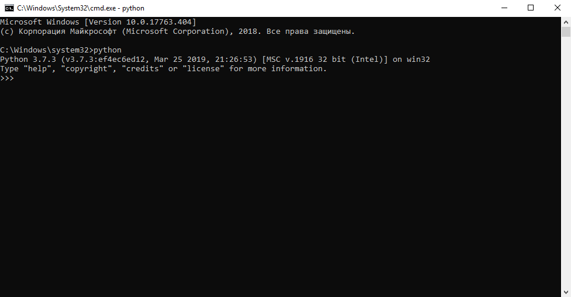

Now you need install module.

Write :

**exit()**

Now at cmd write this:

**pip install tkcolorpicker**

**pip install Pillow**

If it install all correction, you can use Dendrophil at double click.

ATTENTION!  
Don’t close second terminal window python.

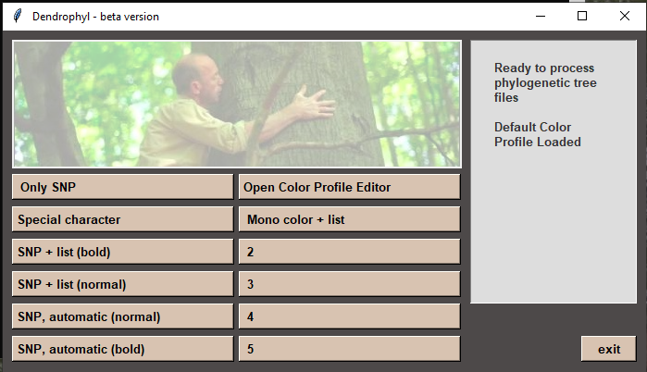

**Install for Linux.( Debian-like system),**

Write at terminal:

Sudo apt-get install python3

Check:

Python3

If installed completed, you can see python! Congratulation!

Now write:

**Exit**()

**sudo** **pip install tkcolorpicker**

**sudo pip install Pillow**

now you can write:

python3 dendro_x.py